THE CONFRATERNITY OFCHRISTIAN MOTHERS
CELEBRATES 100th ANNIVERSARY

The Confraternity of Christian Mothers of Sacred Heart Parish, Hallettsville, celebrated the 100th Anniversary of its organization on July 24, 2011. The celebration began with Mass at 10:30 a.m. with Bishop David Fellhauer of Victoria as main celebrant. Rev. John Peters, Pastor, concelebrated with Deacon Joey Targac assisting. Bishop Fellhauer delivered an inspiring homily and stressed the importance of parents being the first teachers of the faith to their children, which begins at home.
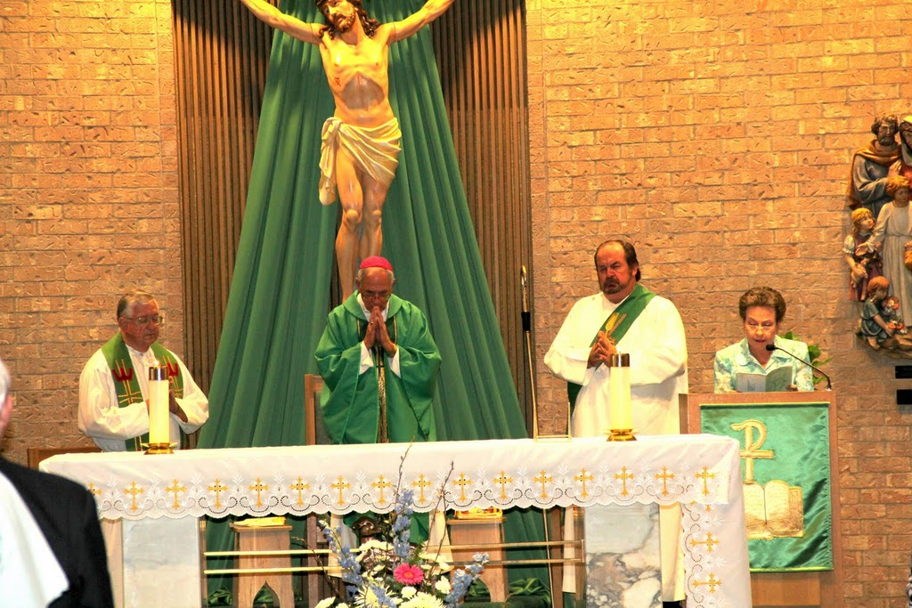
At the altar from left are Father John Peters, pastor at Sacred Heart Church, Bishop David E. Fellhauer, and Deacon Joey Targac. At the ambo is the confraternity’s president, Barbara Grahmann.

Following the Mass, the celebration continued at the Family Center with a catered meal served to 180 members and guests.
The Confraternity of Christian Mothers of Sacred Heart Parish was granted affiliation by the Archconfraternity of Christian Mothers of Pittsburgh, Pennsylvania on July 16, 1911. However, organizational ceremonies were not conducted until July 26, 1915. The following Christian ladies were charter members: Ana Christ, Emma Etzler, Francisca Woitaske, Frederica Pechacek, Francisca Kopecky, Bernadina Huser, Wilhemina Grahmann, Bertha Grafe, Christina Bludau, Marie Peselman, Katherina Haas, Elizabeth Hermes, Bernadina Diersing, Marie Hermes, and Antonia Dworsky.
The society in Hallettsville was originally a German organization, but in the 1930's the organization adopted English as the official language.
With the patroness of the Christian Mothers, the Blessed Mother, centrally displayed, the Family Center was beautifully decorated with flowers and greenery. This display was surrounded by mementos from the past, which brought back fond memories for many. Inspirational plaques depicting the virtues of Faith, Family, Love, Prayer and Laughter were displayed as a reminder of their importance in daily life.
Father John Peters gave the blessing before the meal. Barbara Grahmann, President, welcomed all members and their families and served as mistress of ceremonies.
The program, organized by the officers, included a history of the organization, which was read by Secretary, Debra Huser.

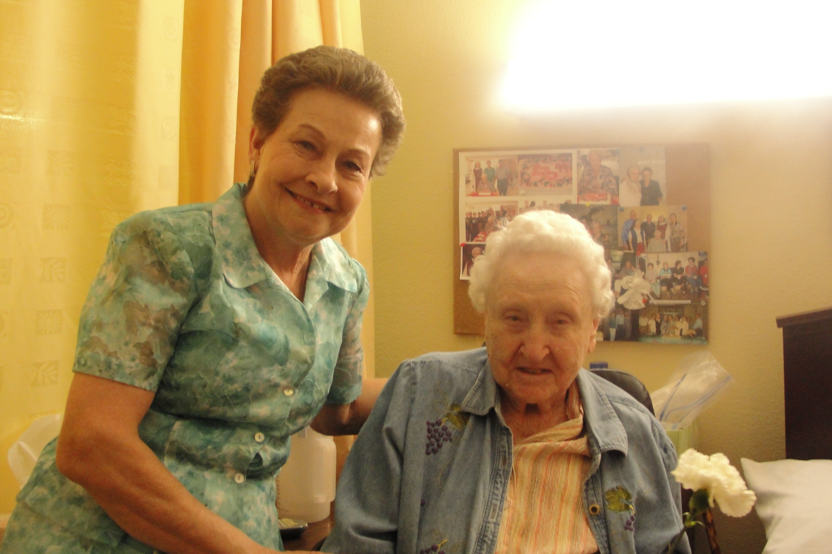
In a Hallettsville nursing home, Barbara Grahmann (left) visits with the confraternity’s oldest member, Mrs. Lena Grafe, who will be 102 years young on Sept. 23, 2011. She has been a member for 79 years and was very active in the organization for many years.

Honorary members, who have been members for more than 50 years, were presented a white carnation and recognized by Vice-President, Sandy Bujnoch. The twenty-nine honorary members are: Lena Grafe, Tillie Schott, Mary Grahmann, Bernadette Bludau, Rose Mary Etzler, Mildred Grahmann, Eleanor Huser, Lucille (Gus, Jr) Werner, Alice Bludau, Emilie Dworsky, Georgie Henke, Ella Mae Bludau, Margaret (Leroy) Bludau, Adela Grahmann, Georgia Haas, Theresa Hemmi, Rosie Bludau, Barbara Kubena, Margaret (Bill) Bludau, Anita Bohuslav, Annie Etzler, Lillian Haas, Bea Heinzel, Marcella Henke, Elizabeth Hermes, Florice Leopold, Mary Migl, Laverne Trojcak, and Rita Zaruba.
Fifty-year pins were awarded to Mrs. Viola (Victor) Grahmann, Gertrude Janak, Anita Kallus, Donna Leopold, Elrose Muenster and Magdalene Steffek. Twenty-five year pins were awarded to Mary Ann Etzler, Josephine Grahmann, Beverly Haas, Kathy Haas, Dorothy Jansky and Evelyn Jansky. Sincere thanks and appreciation were expressed to all these honorees for their dedication in keeping the Christian Mothers Society active for 100 years. 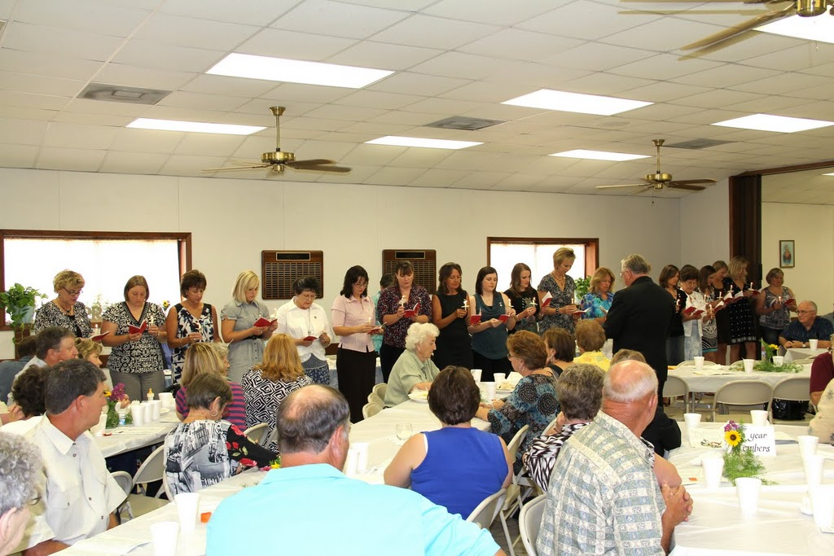

The society was happy to welcome twenty new members in a very impressive ceremony. Inducted into the organization by Father John Peters were the following: Franaces Bock, Alicia Garcia, Nanci Hadash, Rachel Hanslik, Dorothy Harper, Renae Harper, Michelle Hall, Wendy Janak, Shirley Johnson, Amy Kubecka, Erin Lyons, Angela McConnell, Patricia Mladenka, Jennifer Noska, Angela Pustka, Melanie Rother, Danielle Sevcik, Leona Steffek, Virginia Warzecha, and Chelsea Wimberly.
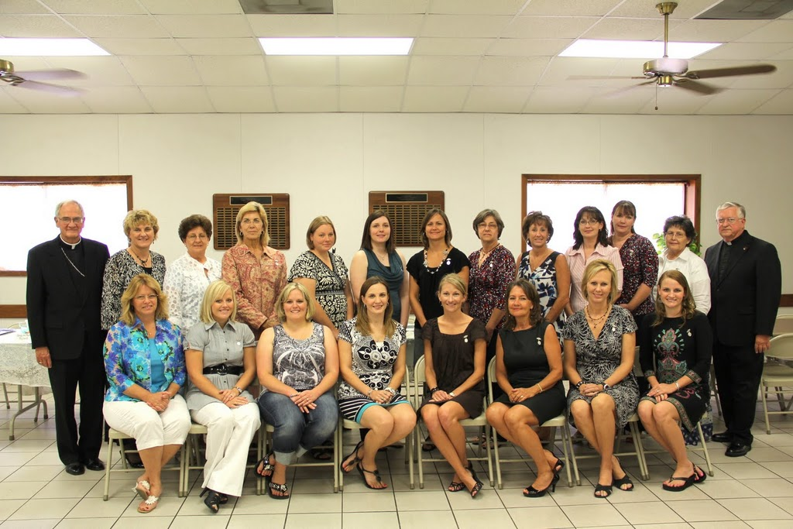
Above are newly inducted members of the confraternity with Bishop David Fellhauer (l.) and Father John Peters (r.).

Following the induction of new members Patricia Mladenka sang a solo of an inspirational hymn to the Blessed Mother “Ave Maria”. This was a special honor for the society because she also sang the same hymn at the 50th anniversary of the Confraternity.
Installation of officers for 2011-2012 was held with Barbara Grahmann installed as president, Sandy Bujnoch, vice-president, Debra Huser, secretary and Rhonda Brown as treasurer.
Barbara Grahmann gave recognition to the following past presidents: Mrs. Annie (Charles) Christ 1915-1922, Mrs. Bertha (Joe) Grafe 1922-1930, Mrs. Emilie (Adolph) Haas 1930-1942, Mrs. Mary (R.M.) Koening 1942-1950, Mrs. Marguerite Grun 1950-1954, Mrs. Annie (Nick) Grahmann 1954-1961, Mrs. Tillie (Louis) Schott 1961-1963, Mrs. Marcella (Henry Joe) Henke, Jr. 1963-1966, Mrs. Agnes (Hilbert) Bludau 1967-1969, Mrs. Laverne (James) Bludau Trojcak 1969-1972, Mrs. Dorothy (Daniel) Rother 1972-1975, Mrs. Rita (Frank) Zaruba 1975-1978, Mrs. Carol (Gilbert) Morisak 1978-1980, Mrs. Barbara (Robert) Grahmann 1980-1983 and 2000-2003, Mrs. Sheryl (Leon) Barnes, Jr. 1983-1985, Mrs. Georgia (Jerome) Haas 1985-1987, Mrs. Cynthia (Ronnie) Dierschke 1987-1988, Mrs. Mary Ann (Kenneth) Etzler 1988-1990 and 1994-1998, Mrs. Maureen (Gene) Schott 1990-1992, Mrs. Bea Heinzel 1992-1994, Mrs. Rhonda (Stanley) Brown 1998-2000, Mrs. Pam (Michael) Etzler 2003-2006, and Mrs. Amy (Kevin) Shimek 2006-2010.
The Christian Mothers Society of Sacred Heart Parish presently consists of 254 members. The activities sponsored by the society include a chicken noodle soup and bunco social in February, blessing of expectant Mothers in April and November, in August a swim social for members and their families at the Lavaca Swimming Pool, sponsoring the Sharing Tree for Christmas gifts for Nursing Home residents, a Christmas party for the children, presenting an embroidered crib quilt (handmade by members) to all new mothers, Baptismal bibs for all newly baptized in the parish, sponsoring the weekly children's bulletin, giving First Communicants Eucharistic pins, awarding of scholarships and numerous other projects.
President, Barbara Grahmann, extended thanks to the officers for their support, the social and decorating committees for their help in planning the celebration and a special thanks to all who attended.
The celebration concluded with Benediction led by Bishop David Fellhauer and everyone singing the hymn "Immaculate Mary".
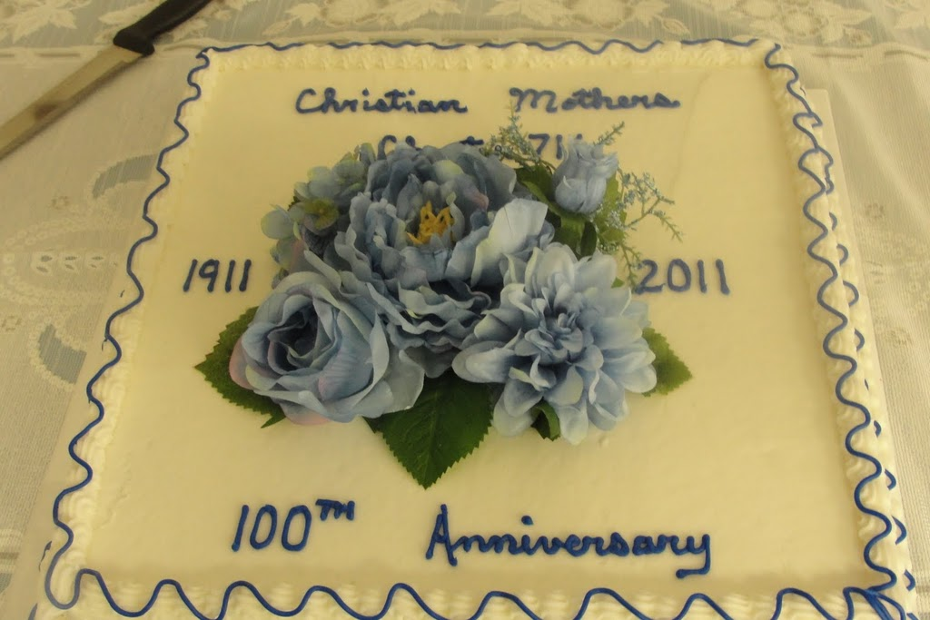

As the history of the first one hundred years of the Christian Mothers comes to a close, a review of the objectives of the organization, as can be found in the Mother Love prayer book, is the same in 2011 as it was in 1911. While the world has changed over the years and raising children in today’s world has certainly changed, good Christian mothers (and fathers) continue to strive to raise their children to be good Catholics through prayer and good example. According to the guidelines, as quoted from the Mother Love prayer book, “The Confraternity of Christian Mothers has for its objective the Christian Home Education of children by truly Christian Mothers. It plans to unite, by the observance of its rules and regulations, all Christian ladies, married or widowed, who are willing to assist one another to attain this noble purpose. Under the special patronage of the ‘Mother of Sorrows’ the members are encouraged joyously and hopefully to undertake the important task of training and sanctifying the young souls entrusted to their care. They are schooled to edify one another by word and deed, to support one another by fervent prayers and thus become the mainstay of spiritual life within their own family and a fruitful source of blessings to the community in which they live. This is the principal aim of all Confraternities affiliated with the Archconfraternity.” This was … and continues to be …. the goal and objective for the Confraternity of Christian Mothers of Sacred Heart Parish today - - just as it was 100 years ago!

