Foundation Day Commemorated By Maryknoll Fathers and Brothers
Maryknoll, New York, July 5, 2011 -- The Maryknoll Fathers and Brothers commemorated its Foundation Day and centennial during a Mass at Maryknoll’s Queens of Apostles Chapel along the Hudson River in Maryknoll, New York, on June 29, 2011. Maryknoll is the foreign mission society of the U.S. Catholic Church.
The commemoration was attended by Maryknoll priests and Brothers and members of the society’s affiliated organizations -- Maryknoll Sisters, Maryknoll Lay Missioners, Maryknoll Affiliates – along with employees and special guests from the Ossining, New York, community and Westchester County.
During 1910, at the 21st Eucharistic Conference in Montreal, Father James A. Walsh of Massachusetts shared his vision of U.S. Catholic mission with Father Thomas F. Price of North Carolina. Realizing they shared a common call to mission, Father Walsh and Father Price collaborated on plans for a mission society within the U.S. Catholic Church. Soon after, the bishops of the United States formally sanctioned the pursuit of their vision to recruit, send and support U.S. missioners around the world.
With this approval, Father Walsh and Father Price traveled to Rome to present their vision of mission. They received the blessing of Pope Pius X on June 29, 1911 (the feast of Saints Peter and Paul), which is the founding day of the Catholic Foreign Mission Society of America that, over the years, has become more well-known as Maryknoll Fathers and Brothers.
Attached Photos:
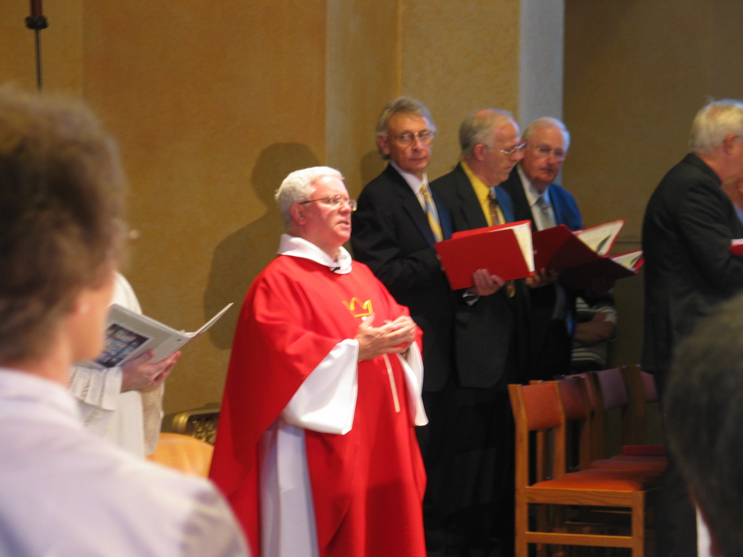
- Father Edward M. Dougherty, superior general, Maryknoll Fathers and Brothers, celebrates Maryknoll’s Foundation Day Mass.
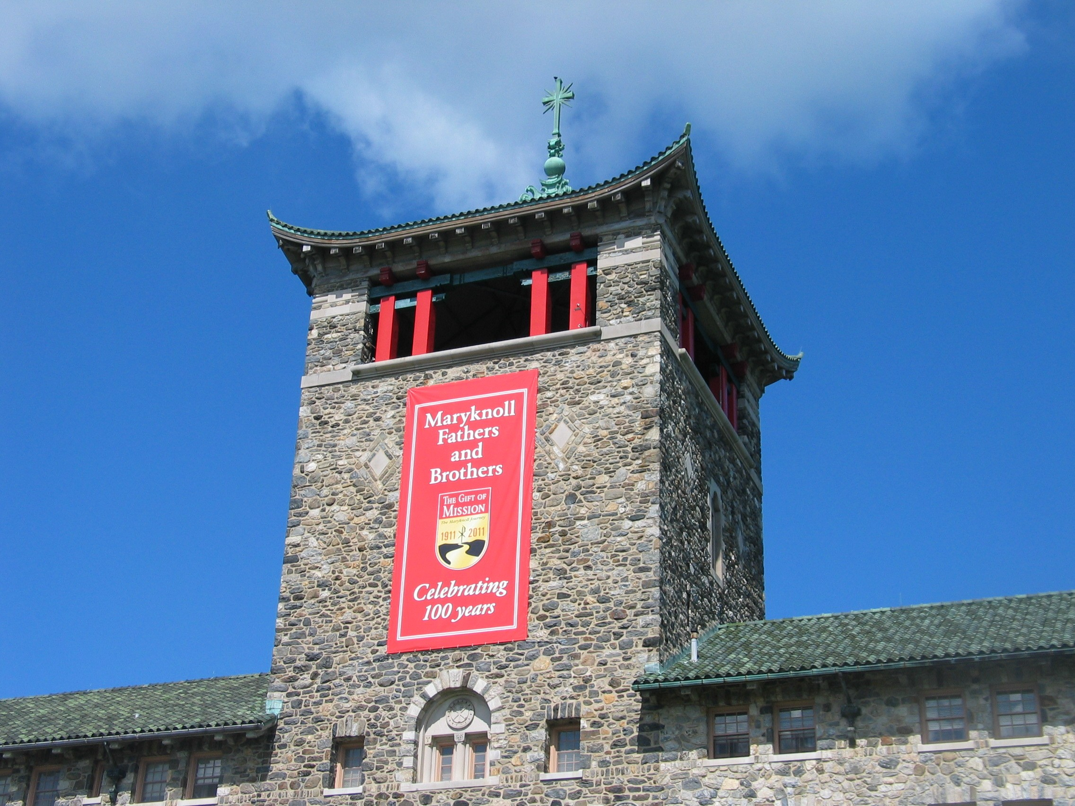
- The Maryknoll Society centennial banner can be seen on its Seminary Building in Maryknoll, New York, which is within Ossining in Westchester County.
Photo Credit: Maryknoll Fathers and Brothers

